Graduate Open House  
for  
Undergraduate Students

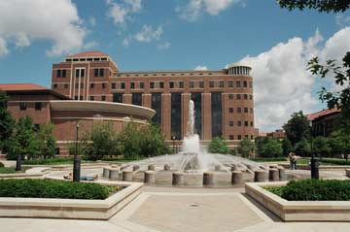

Brian Lamb

School of Communication

Location: Beering Hall Lobby & 1245

**Please join us to learn more about Purdue’s Communication Graduate Program!  
Refreshments will be served**

Date: Wednesday, October 2nd

Any Time Between: 1:30 - 3:30 pm